**R Code for Examples in the book**

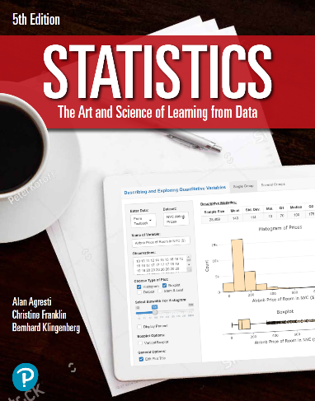

***“Statistics: The Art and Science of Learning from Data”***

**by Agresti, Franklin and Klingenberg, 5th edition**

**Chapter 6**

**Example 7: Talk Time on Smartphones – Finding Normal Probabilities**

## To find the probability that smartphones have a talk-time 1.25 standard deviations below the mean, you can use

pnorm(230, mean = 330, sd = 80)

## [1] 0.1056498

## or

pnorm(-1.25)

## [1] 0.1056498

## To find the probability that smartphones have a talk-time 1.25 standard deviations above the mean, you can use

pnorm(430, mean = 330, sd = 80, lower = FALSE)

## [1] 0.1056498

## or

pnorm(1.25, lower = FALSE)

## [1] 0.1056498

## To find the probability that smartphones have a talk-time 1.25 standard deviations within the mean, you can use

pnorm(430, mean = 330, sd = 80) - pnorm(230, mean = 330, sd = 80)

## [1] 0.7887005

## or

pnorm(1.25) - pnorm(-1.25)

## [1] 0.7887005